Predicting Stock Market Movements Using Long Short Term Memory (LSTM)

Achmad Fauzan

*Computer Science Department*

*School of Computer Science*

Bina Nusantara University

Jakarta, Indonesia 11480

[achmad.fauzan002@binus.ac.id](mailto:achmad.fauzan002@binus.ac.id)

Nicholas Nathaniel

*Computer Science Department*

*School of Computer Science*

Bina Nusantara University

Jakarta, Indonesia 11480

[nicholas.nathaniel002@binus.ac.id](mailto:nicholas.nathaniel002@binus.ac.id)

Maria SusanAnggreainy

*Computer Science Department*

*BINUS Graduate Program*

*Doctor of Computer Science*

Bina Nusantara University

Jakarta, Indonesia 11480

[maria.susan001@binus.ac.id](mailto:maria.susan001@binus.ac.id)

Afdhal Kurniawan

*Computer Science Department*

*School of Computer Science*

Bina Nusantara University

Jakarta, Indonesia 11480

[Afdhal.kurniawan@binus.ac.id](mailto:Afdhal.kurniawan@binus.ac.id)

*Abstract*— This paper explores the use of artificial intelligence (AI) in predicting stock market movements and building optimal portfolios. It reviews literature on AI and machine learning algorithms for stock market forecasting, including decision trees, random forest, gradient boosting, LSTM networks, and DNNs. The research methodology involves using LSTM networks to predict stock performance. The study aims to combine AI with human expertise to develop an intelligent trading system. The findings emphasize the importance of selecting appropriate AI approaches for accurate predictions and optimal portfolio management. The results of this study state that with LSTM we can predict stock prices that are very close to their real prices. The average LSTM method in predicting stock prices is about 97.2938%. Average error obtained when using LSTM 2.3223%.

Keywords— Stock Market, Predicting, Movements, Portfolio, Artificial Intelligence, Optimization.

# Introduction

Predicting Stock Market Movements to Build an Optimal Portfolio Using Artificial Intelligence is one of the most challenging problems in time series data analysis. How to accurately predict Stock Market Movements to Build an Optimal Portfolio is an open question in finance and academia. Predicting Stock Market Movements to Build an Optimal Portfolio is a difficult task, due to the complexity and dynamics of the market and the many obscure and interrelated factors involved. Economic analysts and stock traders were the early pioneers who did stock performance predictions. In recent decades, thousands of books on stock trading have been published.

Many economic analysts and stock traders have studied the historical patterns of financial time series data and have proposed various methods for Predicting Stock Market Movements. In order to achieve a promising performance, most of these methods require careful selection of index variables and finding the sharing features among the distinguished stocks. Additionally, these methods often involve complex statistical and machine learning techniques, such as neural networks, decision trees, and regression analysis, to identify patterns and trends in the data. They also require continuous monitoring and updating to account for changes in the market and the economy.

The initial contribution of this study is the creation of an intelligent trading system by combining AI with the experience of human stock traders. Important index factors given by economic experts and stock traders are employed in this study to train an artificial neural network to predict future stock performance. The second contribution of this research is the validation of the efficacy of human stock traders' expertise and diverse investment techniques in the development of a successful smart trading system. What index characteristics are most relevant, and how to do stock performance prediction to maximize income while minimizing investment risk, are studied in this study. This study focuses on Indonesian stock data in order to investigate viable investment algorithms for the Indonesian stock market.

# Literature review

In order to create the optimum portfolio for the stock market, there has recently been a lot of interest in applying artificial intelligence (AI) and machine learning (ML) algorithms to anticipate stock market moves [1]–[3]. Patalay and Bandlamudi proposed an AI and ML-based decision support system for stock portfolio selection [4]. To predict stock prices and optimize the portfolio, the system employs multiple techniques such as decision trees, random forest, and gradient boosting [5]. Chung and Shin suggested a long short-term memory (LSTM) network optimized by a genetic algorithm for stock market prediction [6]. The approach optimizes the hyperparameters of the LSTM network, which is used to forecast future stock values, using a genetic algorithm.

Other research has concentrated on specific AI and ML techniques for stock market forecasting. For example, proposed using deep neural networks (DNN) to forecast stock performance [7]. The suggested method extracts characteristics from the input data using a stacked autoencoder and then trains a DNN to forecast stock performance. Similarly, Lanbouri and Achchab employed high-frequency data to anticipate stock values using a long-short term memory (LSTM) network [8]. The research shows that LSTM networks can handle complex temporal correlations in financial data, long short-term memory (LSTM) is an improved subset of the RNN method that used in the deep learning area [9]–[12]. These findings emphasize the significance of using the right AI and ML approaches for specific tasks like stock market prediction and portfolio management. Gupta, Bhatia, Dave, and Jain proposed an AI and ML-based data mining system for stock market prediction [13]. To predict stock prices and optimize the portfolio There are two approaches of predicting stock market behaviour. The first one is based on the prediction of future price values of a stock. The second is based on predicting the future price direction of a stock, i.e. guessing whether the price will rise or fall the next day, or in a couple of days (trend forecasting). In a journal written by Vishal Dineshkumar Soni, states that the prediction results of AI are very good [14]. In a 2019 journal written by Bharne and Prabhune, they used Machine Learning and the KNN Method in their research [15].

In conclusion, the employment of AI and machine learning algorithms in stock market prediction and portfolio management has yielded encouraging outcomes [16], [17]. To anticipate stock prices and improve portfolios, researchers have proposed numerous strategies such as decision trees, random forest, gradient boosting, LSTM networks, and DNNs [18]–[20]. It is critical to select appropriate strategies for certain activities in order to achieve accurate predictions and optimal portfolio management[21].

# METHODOLOGY

The method that will be used in this research to predict the best stocks is Long Short Term Memory (LSTM). LSTM networks are extensions of Recurrent Neural Networks (RNNs) introduced primarily to deal with situations where RNNs fail. A fundamental difference between RNN and LSTM architectures is that the hidden layer of LSTM is the gate unit or gate cell. It consists of four layers that interact in such a way as to produce the state of the cell as well as the output of that cell. The LSTM network operates by first receiving the input data and then deciding how much of the prior state to forget using the forget gate. The input gate then chooses how much fresh data to store in the memory cell. After that, the output gate determines how much information to output from the memory cell.

## Receiving the input data

The first step is to get the data and load it into memory. Our stock data will come from the Yahoo Finance website. Yahoo Finance provides a wealth of financial market data and tools to find interesting investments. In the data we take consists of many company stocks. Such as Apple, Amazon, Google, Microsoft, and even bitcoin data. In this data, the stock price movement starts from 2013 - 2022. We will download the market data from Yahoo Finance using the yfinance module, which provides a threaded and Python way to do so.

## Get the Moving Average (MA)

The moving average (MA) is a simple technical analysis technique that smooths out price data by calculating an average price that is continually updated. The average is calculated over a given time period, such as 10 days, 20 minutes, 30 weeks, or any time period selected by the trader. Figure 1, Figure 2, Figure 3, and Figure 4 show the moving averages for 10, 20, 50 days, and also show the adjusted close.

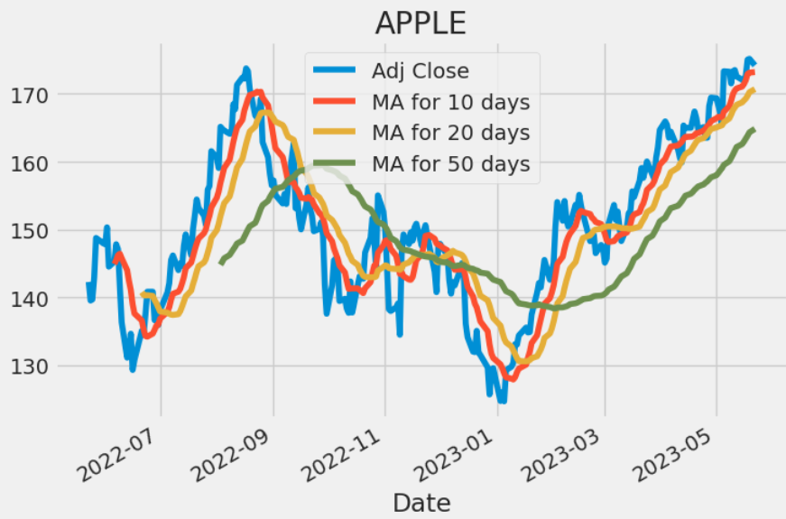

Fig. 1 Apple share price movement over one year

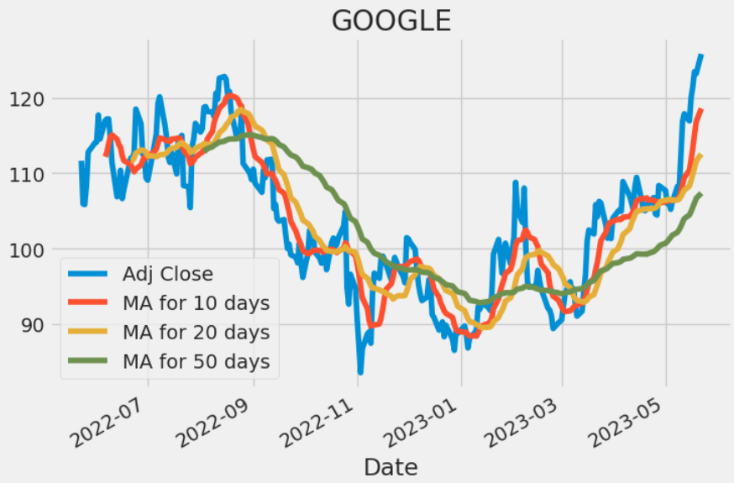

Fig. 2 Google share price movement over one year

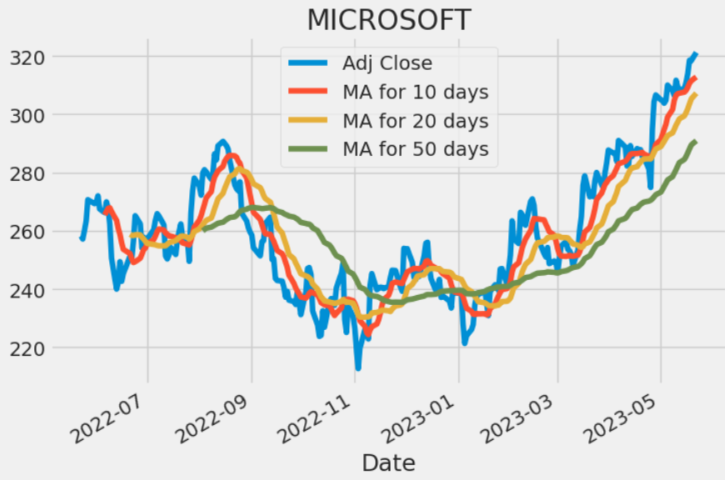

Fig. 3 Microsoft share price movement over one year

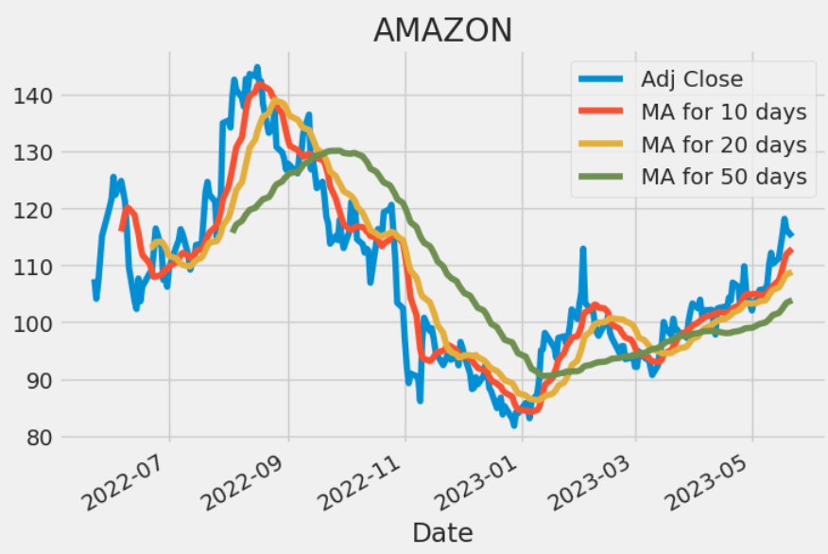

Fig. 4 Amazon share price movement over one year

## Analyze daily return of the stock on average

Now that we've completed some preliminary research, let's delve a bit further. We're now going to look at the stock's risk. To do so, we'll need to look at the stock's daily movements rather than just its absolute value. Let us now utilize pandas to get the daily returns for the Apple stock. In Figure 5, Figure 6, Figure 7, and Figure 8, the average daily return using a histogram is shown.

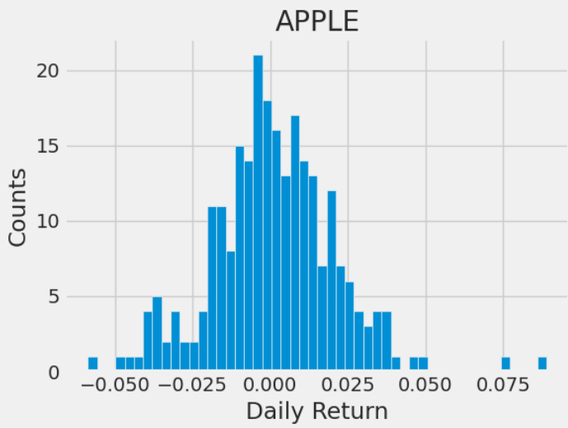

Fig. 5 Stock price risk on Apple

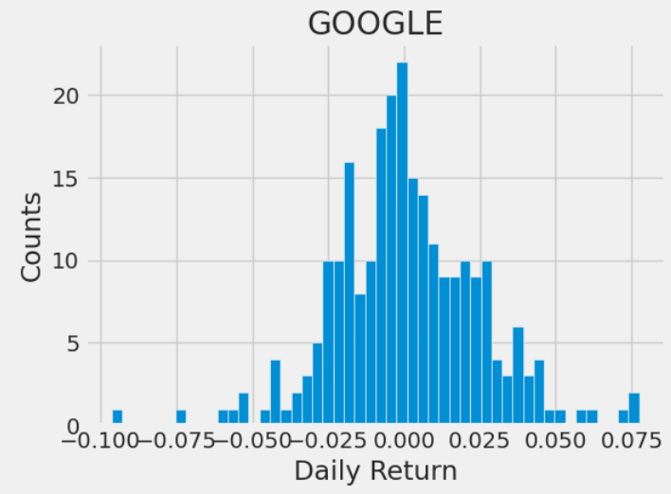

Fig. 6 Stock price risk on Google

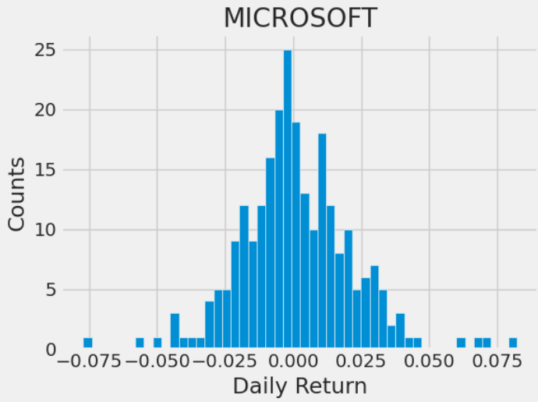

Fig. 7 Stock price risk on Microsoft

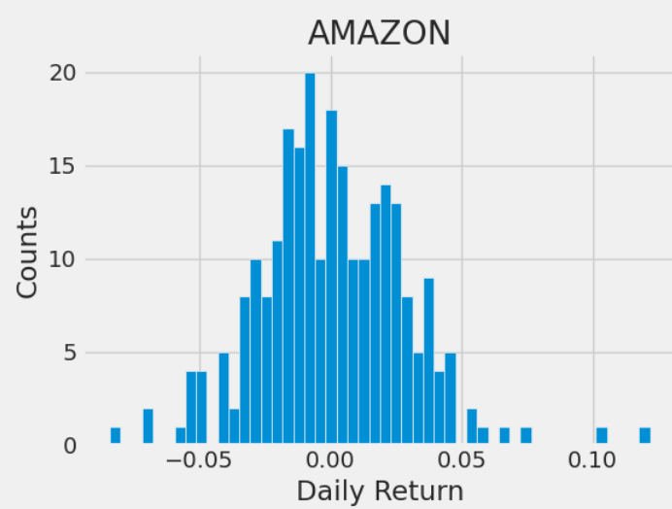

Fig. 8 Stock price risk on Amazon

## Get the risk value of a particular stockThe word “data” is plural, not singular.

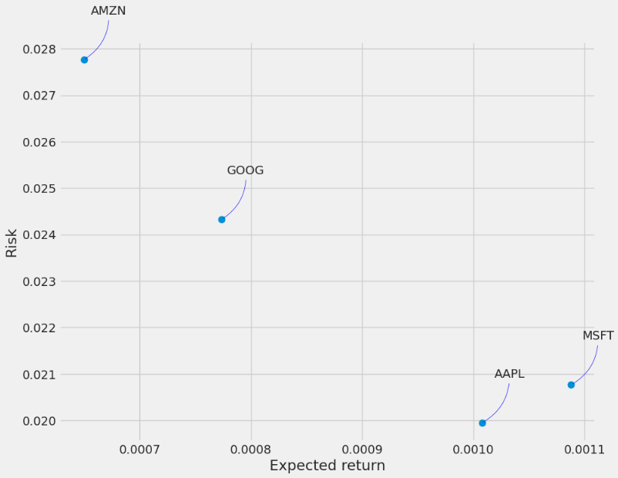

Fig. 9 Return risks when investing in Amazon, Google, Apple, Microsoft

Based on Figure 9, AMZN has the highest risk and lowest expected return. Then in this picture there is something interesting because MSFT and AAPL have adjacent positions. MSFT has a higher expected return than AAPL but has a higher risk than AAPL, so AI will prefer AAPL because it has the lowest risk.

# RESULT

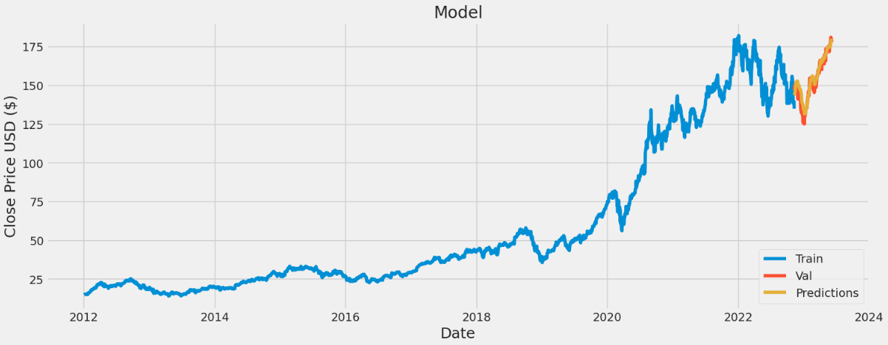

Fig. 10 Prediction Apple stock results using LSTM

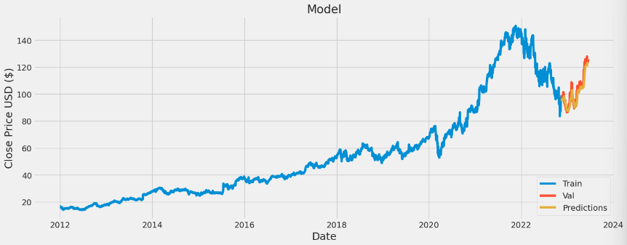

Fig. 11 Prediction Google stock results using LSTM

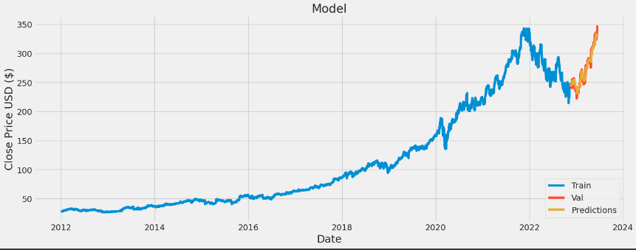

Fig. 11 Prediction Microsoft stock results using LSTM

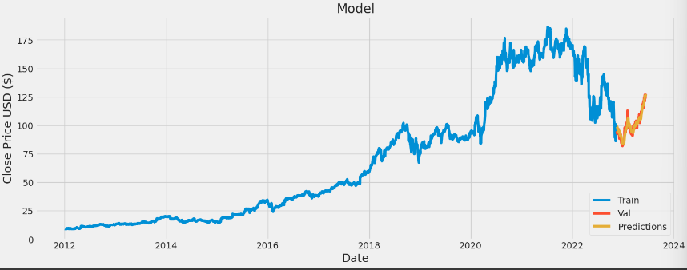

Fig. 12 Prediction Amazon stock results using LSTM

Figure 10, 11, 12, 13 shows the graph of LSTM prediction results with closing stock prices. In the Long Short Term Memory (LSTM) implementation that uses python in predicting the stock market in the dataset. Figure 10 shows the results of predicting the stock market using LSTM. In our research, we use stock data to predict stock prices in a certain time. In the graph we plotted, we used 87 units of LSTM to determine the accurate stock price. In our graph, the x-axis defines the movement of the stock price each year, while the y-axis defines the development of the selling price.

**TABLE I.** Comparison of the close stock price with the LSTM quotation

|  |  |  |  |  |  |
| --- | --- | --- | --- | --- | --- |
| Company | Date | Close | Predictions | Calculation | |
| Accuracy | Error |
| Apple | 2022-11-10 | 146.8699 | 143.5350 | 97.73% | 2.27% |
| 2023-06-02 | 180.9499 | 177.6458 | 98.176% | 1.824% |
| Amazon | 2022-11-11 | 149.6999 | 144.0239 | 96.21% | 3.79% |
| 2023-06-15 | 127.1100 | 133.8545 | 94.639% | 5.307% |
| Microsoft | 2022-11-18 | 97.8000 | 99.5942 | 98.165% | 1.835% |
| 2023-06-15 | 125.7900 | 126.8816 | 99.133% | 0.867% |
| Google | 2022-11-18 | 97.8000 | 99.5942 | 98.165% | 1.835% |
| 2023-06-15 | 125.7900 | 126.8816 | 99.133% | 0.867% |

In figure 10, it can be seen that the prediction results using Long Short Term Memory (LSTM) are close to the actual stock price. Table I includes 4 predictions from all tested stock markets namely Apple, Amazon, Microsoft, and Google. Where in the first column presents the prediction data of Apple, the second column Amazon, the third Microsoft, and the last column Google. Table 1 shows the comparison between the close stock price and the LSTM prediction result. For the difference in numbers predicted by LSTM, it is only about 3 numbers different from the actual stock price. The average LSTM method in predicting stock prices is about 97.2938%. Average error obtained when using LSTM 2.3223%. The Long Short Term Memory (LSTM) method is very suitable in predicting stock prices, because it has a relatively low difference with the real price.

# CONCLUSION

In conclusion, this research utilized the Long Short-Term Memory (LSTM) method to predict stock market movements and build an optimal portfolio. By combining AI techniques with human expertise, the study demonstrated the potential of developing an intelligent trading system. The methodology involved gathering and analyzing stock market data, calculating moving averages, and assessing risk. The findings highlight the importance of selecting appropriate AI approaches for accurate predictions and optimal portfolio management. LSTM networks proved effective in handling complex temporal correlations in financial data. Continuous model updating and adaptation to market changes are crucial for successful outcomes in stock market prediction and portfolio optimization. Overall, this research contributes insights into the effective utilization of AI in finance and emphasizes the role of intelligent trading systems in enhancing decision-making processes.

##### Refereces

[1] K. H. Sadia, A. Sharma, A. Paul, S. Padhi, and S. Sanyal, “Stock market prediction using machine learning algorithms,” *International Journal of Recent Technology and Engineering*, vol. 8, no. 4, pp. 280–283, Apr. 2019, doi: 10.14201/adcaij20198497116.

[2] “Techniques Using Artificial Intelligence to Solve Stock Market Forecast, Sales Estimating and Market Division Issues,” *Journal of Contemporary Issues in Business and Government*, vol. 27, no. 03, Apr. 2021, doi: 10.47750/cibg.2021.27.03.030.

[3] X. Zhong and D. Enke, “Predicting the daily return direction of the stock market using hybrid machine learning algorithms,” *Financial Innovation*, vol. 5, no. 1, Dec. 2019, doi: 10.1186/s40854-019-0138-0.

[4] S. Patalay and M. R. Bandlamudi, “Decision support system for stock portfolio selection using artificial intelligence and machine learning,” *Ingenierie des Systemes d’Information*, vol. 26, no. 1, pp. 87–93, Feb. 2021, doi: 10.18280/isi.260109.

[5] M. C. Thrun, “Exploiting Distance-Based Structures in Data Using an Explainable AI for Stock Picking,” *Information (Switzerland)*, vol. 13, no. 2, Feb. 2022, doi: 10.3390/info13020051.

[6] H. Chung and K. S. Shin, “Genetic algorithm-optimized long short-term memory network for stock market prediction,” *Sustainability (Switzerland)*, vol. 10, no. 10, Oct. 2018, doi: 10.3390/su10103765.

[7] Y. Gu, T. Shibukawa, Y. Kondo, S. Nagao, and S. Kamijo, “Prediction of stock performance using deep neural networks,” *Applied Sciences (Switzerland)*, vol. 10, no. 22, pp. 1–20, Nov. 2020, doi: 10.3390/app10228142.

[8] Z. Lanbouri and S. Achchab, “Stock market prediction on high frequency data using long-short term memory,” in *Procedia Computer Science*, Elsevier B.V., 2020, pp. 603–608. doi: 10.1016/j.procs.2020.07.087.

[9] Z. Hao, H. Zhang, and Y. Zhang, “Stock Portfolio Management by Using Fuzzy Ensemble Deep Reinforcement Learning Algorithm,” *Journal of Risk and Financial Management*, vol. 16, no. 3, p. 201, Mar. 2023, doi: 10.3390/jrfm16030201.

[10] M. Nabipour, P. Nayyeri, H. Jabani, A. Mosavi, E. Salwana, and S. Shahab, “Deep learning for stock market prediction,” *Entropy*, vol. 22, no. 8, Aug. 2020, doi: 10.3390/E22080840.

[11] M. Khushi and T. L. Meng, “Reinforcement learning in financial markets,” *Data*, vol. 4, no. 3. MDPI, Sep. 01, 2019. doi: 10.3390/data4030110.

[12] Z. Hu, Y. Zhao, and M. Khushi, “A survey of forex and stock price prediction using deep learning,” *Applied System Innovation*, vol. 4, no. 1. MDPI AG, pp. 1–30, Mar. 01, 2021. doi: 10.3390/ASI4010009.

[13] A. Gupta, P. Bhatia, K. Dave, and P. Jain, “Stock Market Prediction Using Data Mining Techniques.” [Online]. Available: http://ssrn.com/link/2019-ICAST.html

[14] V. D. Soni, “Prediction of Stock Market Values using Artificial Intelligence International Journal of Advanced Research in Electrical, Electronics and Instrumentation Engineering Prediction of Stock Market Values using Artificial Intelligence,” *Article in International Journal of Advanced Research in Electrical Electronics and Instrumentation Engineering*, 2018, doi: 10.15662/IJAREEIE.2018.0704057.

[15] S. Mokhtari, K. K. Yen, and J. Liu, “Effectiveness of Artificial Intelligence in Stock Market Prediction based on Machine Learning,” Jun. 2021, doi: 10.5120/ijca2021921347.

[16] M. Iyyappan, S. Ahmad, S. Jha, A. Alam, M. Yaseen, and H. A. M. Abdeljaber, “A Novel AI-Based Stock Market Prediction Using Machine Learning Algorithm,” *Sci Program*, vol. 2022, 2022, doi: 10.1155/2022/4808088.

[17] S. Mehtab and J. Sen, “XXX-X-XXXX-XXXX-X/XX/$XX.00 ©20XX IEEE Stock Price Prediction Using Convolutional Neural Networks on a Multivariate Timeseries.”

[18] D. Selvamuthu, V. Kumar, and A. Mishra, “Indian stock market prediction using artificial neural networks on tick data,” *Financial Innovation*, vol. 5, no. 1, Dec. 2019, doi: 10.1186/s40854-019-0131-7.

[19] Dr. D. Durga Bhavani and Ch. Sarada, “Analysis of Stock Market Price Prediction of Indian Finance Companies using Artificial Neural Network Approaches,” *CVR Journal of Science & Technology*, vol. 20, no. 1, pp. 43–49, Jun. 2021, doi: 10.32377/cvrjst2006.

[20] S. Mukherjee, B. Sadhukhan, N. Sarkar, D. Roy, and S. De, “Stock market prediction using deep learning algorithms,” *CAAI Trans Intell Technol*, Mar. 2021, doi: 10.1049/cit2.12059.

[21] FARES SAYAH, “Stock Market Analysis + Prediction using LSTM,” *kaggle*, Jan. 15, 2023.